Exercise 1: Configuring a Basic Spring Application:
applicationContext.xml:
<?xml version="1.0" encoding="UTF-8"?>
<beans xmlns="http://www.springframework.org/schema/beans"
xmlns:xsi="http://www.w3.org/2001/XMLSchema-instance"
xsi:schemaLocation="
http://www.springframework.org/schema/beans
https://www.springframework.org/schema/beans/spring-beans.xsd">
<bean id="bookRepository" class="com.library.repository.BookRepository"/>
<bean id="bookService" class="com.library.service.BookService"/>
</beans>
LibraryManagement.java:
package com.library;
import org.springframework.context.support.ClassPathXmlApplicationContext;
import com.library.service.BookService;
public class LibraryManagementApplication {
public static void main(String[] args) {
try (ClassPathXmlApplicationContext ctx =
new ClassPathXmlApplicationContext("applicationContext.xml")) {
BookService svc = ctx.getBean(BookService.class);
System.out.println(svc.listBooks());
}
}
}
BookService.java:
package com.library.service;
import com.library.repository.BookRepository;
public class BookService {
private BookRepository repo;
public String listBooks() {
return repo.findAll();
}
public void setRepo(BookRepository repo) {
this.repo = repo;
}
}
BookRepository.java:
package com.library.repository;
public class BookRepository {
public String findAll() {
return "📚 42 books (dummy DB)";
}
}
Pom.xml:
<project xmlns="http://maven.apache.org/POM/4.0.0"
xmlns:xsi="http://www.w3.org/2001/XMLSchema-instance"
xsi:schemaLocation="http://maven.apache.org/POM/4.0.0
http://maven.apache.org/xsd/maven-4.0.0.xsd">
<modelVersion>4.0.0</modelVersion>
<groupId>com.library</groupId>
<artifactId>LibraryManagement</artifactId>
<version>1.0-SNAPSHOT</version>
<properties>
<spring.version>5.3.38</spring.version>
<maven.compiler.source>1.8</maven.compiler.source>
<maven.compiler.target>1.8</maven.compiler.target>
</properties>
<dependencies>
<dependency>
<groupId>org.springframework</groupId>
<artifactId>spring-context</artifactId>
<version>${spring.version}</version>
</dependency>
</dependencies>
</project>
Exercise 2: Implementing Dependency Injection:
applicationContext.xml:
<?xml version="1.0" encoding="UTF-8"?>
<beans xmlns="http://www.springframework.org/schema/beans"
xmlns:xsi="http://www.w3.org/2001/XMLSchema-instance"
xsi:schemaLocation="
http://www.springframework.org/schema/beans
https://www.springframework.org/schema/beans/spring-beans.xsd">
<bean id="bookRepository" class="com.library.repository.BookRepository"/>
<bean id="bookService" class="com.library.service.BookService">
<property name="repo" ref="bookRepository"/>
</bean>
</beans>
After running LibraryManagementApplication, it shows:
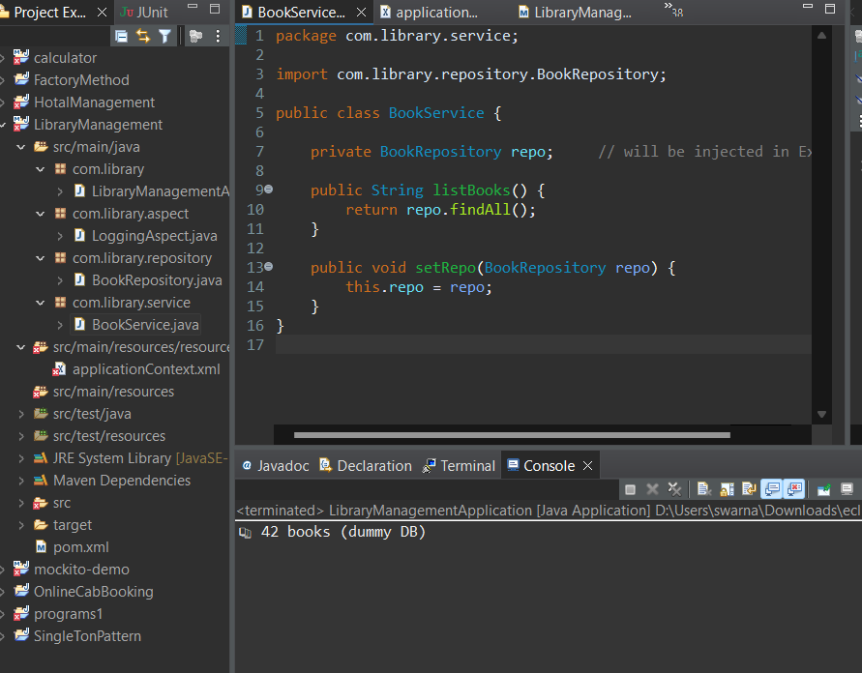

Exercise 3: Implementing Logging with Spring AOP
LoggingAspect.java:
package com.library.aspect;
import org.aspectj.lang.ProceedingJoinPoint;
import org.aspectj.lang.annotation.Around;
import org.aspectj.lang.annotation.Aspect;
@Aspect
public class LoggingAspect {
@Around("execution(* com.library.service.*.*(..))")
public Object logExecutionTime(ProceedingJoinPoint joinPoint) throws Throwable {
long start = System.currentTimeMillis();
Object result = joinPoint.proceed(); // continue execution
long timeTaken = System.currentTimeMillis() - start;
System.out.println("⏱️ Method " + joinPoint.getSignature() + " took " + timeTaken + " ms");
return result;
}
}
Pom.xml:
<project xmlns="http://maven.apache.org/POM/4.0.0"
xmlns:xsi="http://www.w3.org/2001/XMLSchema-instance"
xsi:schemaLocation="http://maven.apache.org/POM/4.0.0
http://maven.apache.org/xsd/maven-4.0.0.xsd">
<modelVersion>4.0.0</modelVersion>
<groupId>com.library</groupId>
<artifactId>LibraryManagement</artifactId>
<version>1.0-SNAPSHOT</version>
<properties>
<spring.version>5.3.38</spring.version>
<maven.compiler.source>1.8</maven.compiler.source>
<maven.compiler.target>1.8</maven.compiler.target>
</properties>
<dependencies>
<dependency>
<groupId>org.springframework</groupId>
<artifactId>spring-context</artifactId>
<version>${spring.version}</version>
</dependency>
<dependency>
<groupId>org.springframework</groupId>
<artifactId>spring-aop</artifactId>
<version>5.3.38</version>
</dependency>
<dependency>
<groupId>org.aspectj</groupId>
<artifactId>aspectjweaver</artifactId>
<version>1.9.21</version>
</dependency>
</dependencies>
</project>
applicationContext.xml:
<?xml version="1.0" encoding="UTF-8"?>
<beans xmlns="http://www.springframework.org/schema/beans"
xmlns:xsi="http://www.w3.org/2001/XMLSchema-instance"
xmlns:aop="http://www.springframework.org/schema/aop"
xsi:schemaLocation="
http://www.springframework.org/schema/beans
https://www.springframework.org/schema/beans/spring-beans.xsd
http://www.springframework.org/schema/aop
https://www.springframework.org/schema/aop/spring-aop.xsd">

<aop:aspectj-autoproxy/>
<bean id="bookRepository" class="com.library.repository.BookRepository"/>
<bean id="bookService" class="com.library.service.BookService">
<property name="repo" ref="bookRepository"/>
</bean>
<bean id="loggingAspect" class="com.library.aspect.LoggingAspect"/>
</beans>
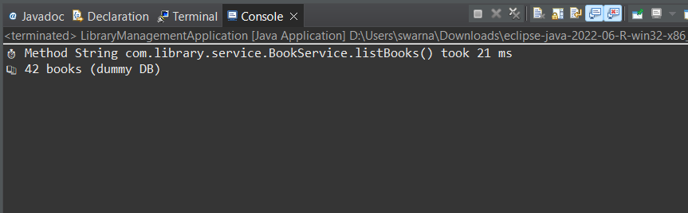
Exercise 4: Creating and Configuring a Maven Project:
Pom.xml:
<project xmlns="http://maven.apache.org/POM/4.0.0"
xmlns:xsi="http://www.w3.org/2001/XMLSchema-instance"
xsi:schemaLocation="http://maven.apache.org/POM/4.0.0
http://maven.apache.org/xsd/maven-4.0.0.xsd">
<modelVersion>4.0.0</modelVersion>
<groupId>com.library</groupId>
<artifactId>LibraryManagement</artifactId>
<version>1.0-SNAPSHOT</version>
<properties>
<spring.version>5.3.38</spring.version>
<maven.compiler.source>1.8</maven.compiler.source>
<maven.compiler.target>1.8</maven.compiler.target>
</properties>
<dependencies>
<dependency>
<groupId>org.springframework</groupId>
<artifactId>spring-context</artifactId>
<version>${spring.version}</version>
</dependency>
<dependency>
<groupId>org.springframework</groupId>
<artifactId>spring-aop</artifactId>
<version>5.3.38</version>
</dependency>
<dependency>
<groupId>org.aspectj</groupId>
<artifactId>aspectjweaver</artifactId>
<version>1.9.21</version>
</dependency>
</dependencies>
<build>
<plugins>
<!-- Java Compiler Plugin -->
<plugin>
<groupId>org.apache.maven.plugins</groupId>
<artifactId>maven-compiler-plugin</artifactId>
<version>3.10.1</version>
<configuration>
<source>1.8</source>
<target>1.8</target>
</configuration>
</plugin>
</plugins>
</build>
</project>
Maven Build:
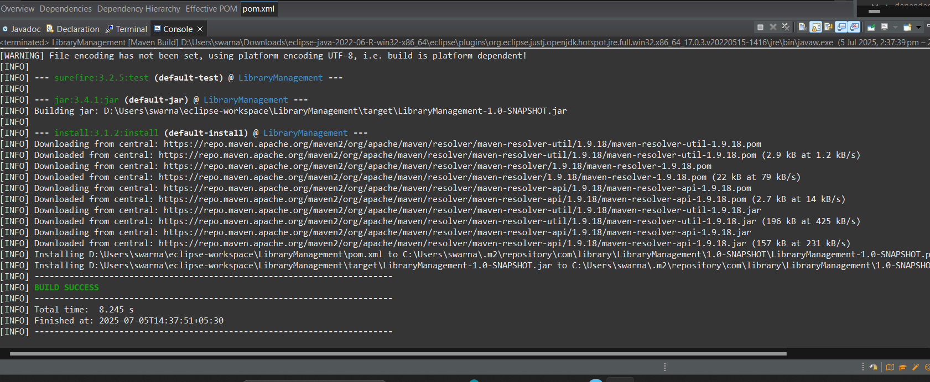
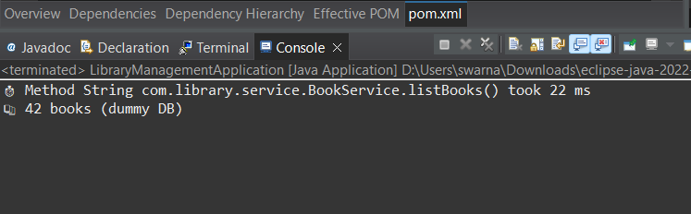
Exercise 5: Configuring the Spring IoC Container
applicationContainer.xml:
<?xml version="1.0" encoding="UTF-8"?>
<beans xmlns="http://www.springframework.org/schema/beans"
xmlns:xsi="http://www.w3.org/2001/XMLSchema-instance"
xsi:schemaLocation="
http://www.springframework.org/schema/beans
https://www.springframework.org/schema/beans/spring-beans.xsd">
<bean id="bookRepository" class="com.library.repository.BookRepository"/>
<bean id="bookService" class="com.library.service.BookService">
<property name="repo" ref="bookRepository"/>
</bean>
</beans>

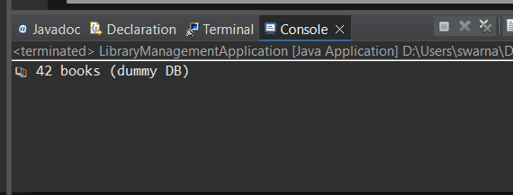
Exercise 6: Configuring Beans with Annotations
BookRepository.java:
package com.library.repository;
import org.springframework.stereotype.Repository;
@Repository
public class BookRepository {
public String findAll() {
return "📚 42 books (annotated)";
}
}
BookService.java:
package com.library.service;
import com.library.repository.BookRepository;
import org.springframework.beans.factory.annotation.Autowired;
import org.springframework.stereotype.Service;
@Service
public class BookService {
@Autowired
private BookRepository repo;
public String listBooks() {
return repo.findAll();
}
}

applicationContext.xml:
<?xml version="1.0" encoding="UTF-8"?>
<beans xmlns="http://www.springframework.org/schema/beans"
xmlns:context="http://www.springframework.org/schema/context"
xmlns:xsi="http://www.w3.org/2001/XMLSchema-instance"
xsi:schemaLocation="
http://www.springframework.org/schema/beans
https://www.springframework.org/schema/beans/spring-beans.xsd
http://www.springframework.org/schema/context
https://www.springframework.org/schema/context/spring-context.xsd">
<context:component-scan base-package="com.library"/>
</beans>
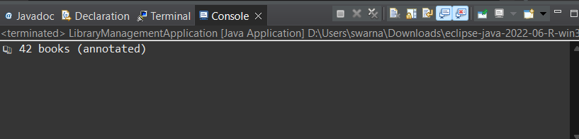
Exercise 7: Implementing Constructor and Setter Injection
LoggerService.java:
package com.library.logging;
public class LoggerService {
public void log(String msg) {
System.out.println("📝 LOG: " + msg);
}
}
BookService.java:
package com.library.service;
import com.library.repository.BookRepository;
import com.library.logging.LoggerService;

public class BookService {
private BookRepository repo;
private LoggerService loggerService;
public BookService(BookRepository repo) {
this.repo = repo;
System.out.println(" Constructor injection: BookRepository");
}
public void setLoggerService(LoggerService loggerService) {
this.loggerService = loggerService;
System.out.println(" Setter injection: LoggerService");
}
public String listBooks() {
if (loggerService != null) loggerService.log("Fetching books...");
return repo.findAll();
}
}
applicationContext.xml:
<beans xmlns="http://www.springframework.org/schema/beans"
xmlns:xsi="http://www.w3.org/2001/XMLSchema-instance"
xsi:schemaLocation="
http://www.springframework.org/schema/beans
https://www.springframework.org/schema/beans/spring-beans.xsd">
<bean id="bookRepository" class="com.library.repository.BookRepository"/>
<bean id="loggerService" class="com.library.logging.LoggerService"/>
<bean id="bookService" class="com.library.service.BookService">
<constructor-arg ref="bookRepository"/>
<property name="loggerService" ref="loggerService"/>
</bean>
</beans>

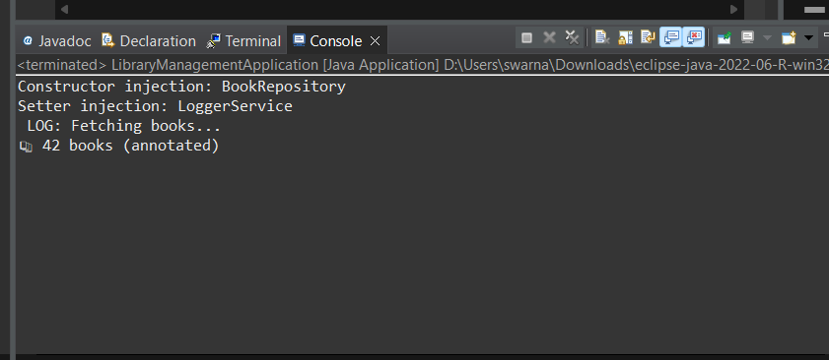
Exercise 8: Implementing Basic AOP with Spring
LoggingAspect.java:
package com.library.aspect;
import org.aspectj.lang.JoinPoint;
import org.aspectj.lang.annotation.After;
import org.aspectj.lang.annotation.Before;
import org.aspectj.lang.annotation.Aspect;
@Aspect
public class LoggingAspect {
@Before("execution(* com.library.service.*.*(..))")
public void logBefore(JoinPoint joinPoint) {
System.out.println("🔍 BEFORE: " + joinPoint.getSignature());
}
@After("execution(* com.library.service.*.*(..))")
public void logAfter(JoinPoint joinPoint) {
System.out.println("✅ AFTER: " + joinPoint.getSignature());
}
}
applicationContext.xml:
<?xml version="1.0" encoding="UTF-8"?>
<beans xmlns="http://www.springframework.org/schema/beans"
xmlns:context="http://www.springframework.org/schema/context"
xmlns:aop="http://www.springframework.org/schema/aop"
xmlns:xsi="http://www.w3.org/2001/XMLSchema-instance"
xsi:schemaLocation="
http://www.springframework.org/schema/beans https://www.springframework.org/schema/beans/spring-beans.xsd
http://www.springframework.org/schema/context https://www.springframework.org/schema/context/spring-context.xsd
http://www.springframework.org/schema/aop https://www.springframework.org/schema/aop/spring-aop.xsd">
<context:component-scan base-package="com.library"/>
<aop:aspectj-autoproxy/>
<bean id="loggingAspect" class="com.library.aspect.LoggingAspect"/>
</beans>
BookService.java:
package com.library.service;
import com.library.repository.BookRepository;
import com.library.logging.LoggerService;
import org.springframework.beans.factory.annotation.Autowired;
import org.springframework.stereotype.Service;
@Service
public class BookService {
private final BookRepository repo;
private LoggerService loggerService;
@Autowired
public BookService(BookRepository repo) {
this.repo = repo;
System.out.println("📦 Constructor injection: BookRepository");
}
@Autowired
public void setLoggerService(LoggerService loggerService) { // optional
this.loggerService = loggerService;
System.out.println("🔧 Setter injection: LoggerService");
}
public String listBooks() {
if (loggerService != null) loggerService.log("Fetching books...");
return repo.findAll();
}
}
LoggerService.java:
package com.library.logging;
import org.springframework.stereotype.Component;
@Component
public class LoggerService {
public void log(String msg) {
System.out.println("📝 LOG: " + msg);
}
}
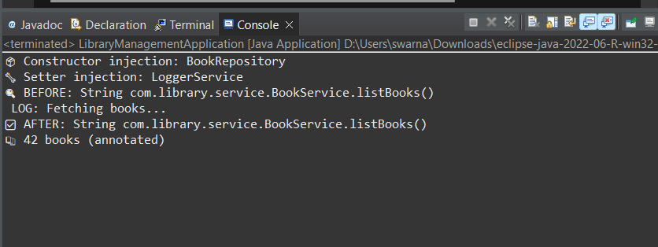
Exercise 9: Creating a Spring Boot Application:
HomeController.java:
package com.library.controller;
import org.springframework.web.bind.annotation.GetMapping;
import org.springframework.web.bind.annotation.RestController;
@RestController
public class HomeController {
@GetMapping("/")
public String home() {
return "Welcome to the Library Management System!";
}
}
BookController.java:
package com.library.controller;
import com.library.model.Book;
import com.library.repository.BookRepository;
import org.springframework.beans.factory.annotation.Autowired;
import org.springframework.web.bind.annotation.*;
import java.util.List;
@RestController
@RequestMapping("/books")
public class BookController {
@Autowired
private BookRepository bookRepository;
@GetMapping
public List<Book> getAllBooks() {
return bookRepository.findAll();
}
}
Book.java:
package com.library.model;
import jakarta.persistence.Entity;
import jakarta.persistence.Id;
@Entity
public class Book {
@Id
private Long id;
private String title;
public Long getId() {
return id;
}
public void setId(Long id) {
this.id = id;
}
public String getTitle() {
return title;
}
public void setTitle(String title) {
this.title = title;
}
}
application.properties:
spring.datasource.url=jdbc:h2:mem:librarydb
spring.datasource.driver-class-name=org.h2.Driver
spring.datasource.username=sa
spring.datasource.password=
spring.jpa.hibernate.ddl-auto=update
spring.h2.console.enabled=true
spring.jpa.show-sql=true
spring.jpa.hibernate.ddl-auto=create
spring.jpa.defer-datasource-initialization=true

localhost:8080/
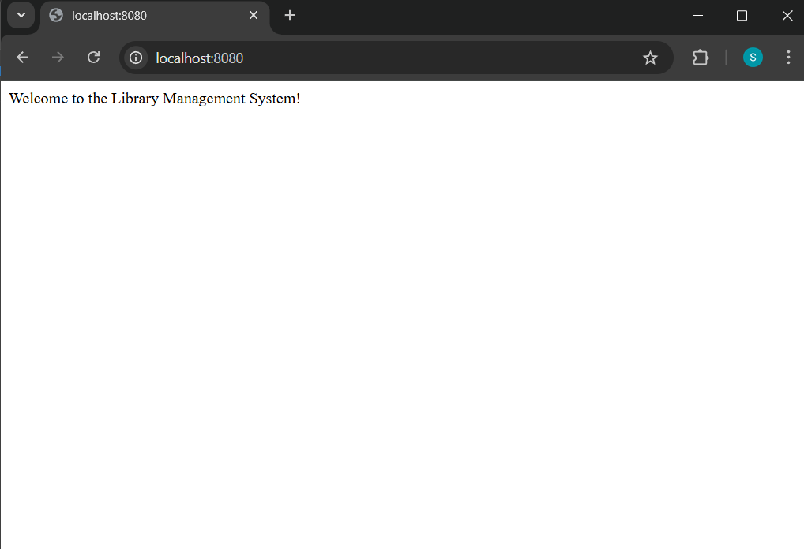
Localhost:8080/books
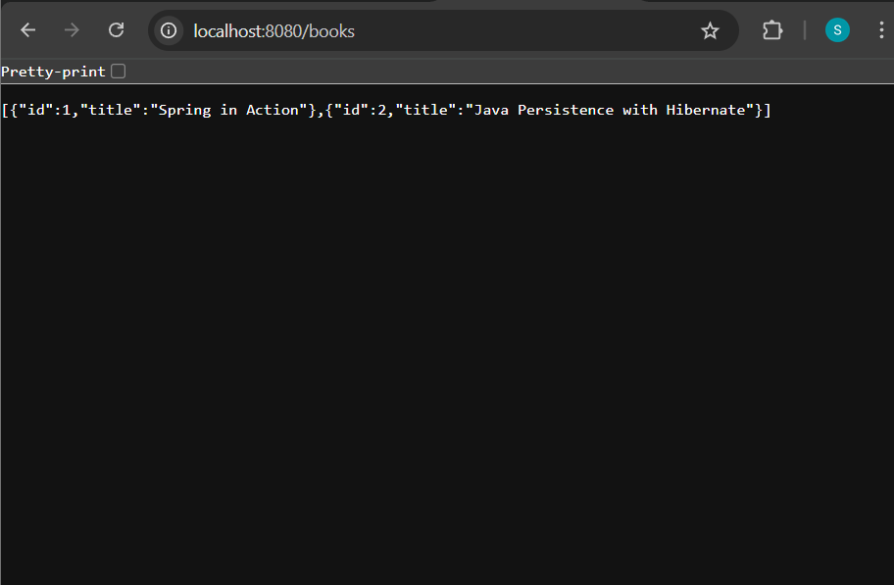

Localhost:h2/console
